
Company
Logotype

Cone Beam Computed Tomography- Report



Porur Dental X-rays & CBCT

Patient Name : Mr. Lakshmi Narayanan | Date of Report : 26.03.2024
Age/ Gender : 57 years/ Male | Region of Interest : CBCT Mandible
Referring doctor: Dr. Hemachandran | Indication : Implant assessment
Clinical Notes: Nil
PATIENT INFORMATION

CBCT- Mandible provided
CBCT – IMAGE DETAILS

RADIOGRAPHIC INTERPRETATION

- Complete loss of crown and root structure in relation to 36, 37.
- In 38, loss of crown structure with remaining radicular portion within the alveolar bone is evident. Distance between the apical portion of root stumps and Inferior alveolar nerve canal is 1.54 mm.
- The tooth 47, 48 is present with central hypodense area within the crown involving the pulp, and causing Periodontal ligament space widening.
- Mesial migration of 47 is evident.
- The alveolar bone in relation to the mandibular ridge is present with normal trabecular pattern.

IMPLANT ASSESSMENT

 | 36 region | 37 region
Sub-Crestal (in mm) | 3.44 | 4.77
Mid- Crestal (in mm) | 4.58 | 7.96
Distance between alveolar ridge and the inferior alveolar nerve canal (in mm) | 14.82 | 11.04
Distance between alveolar ridge and the inferior border of mandible (in mm) | 23.66 | 21.24

RADIOGRAPHIC IMPRESSION

- Root Stumps: 38.
- Dental caries with periapical pathology: 47, 48.

Kindly correlate with clinical findings


IMAGES FOR REFERENCE

RECONSTRUCTED PANORAMIC VIEW

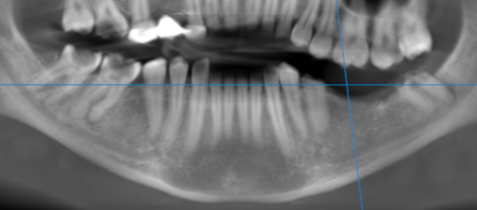

3-DIMENSIONAL VIEW
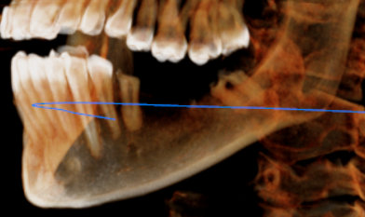

CROSS SECTIONAL VIEW

36 region | 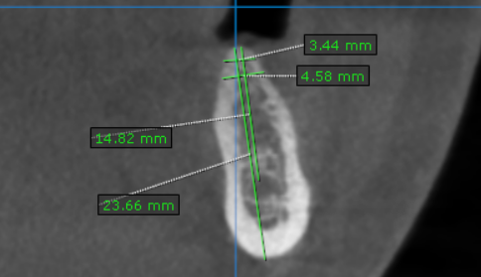
37 region | 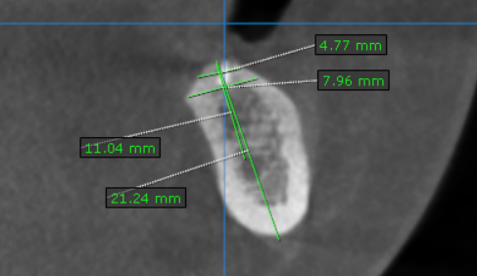

**** End of report ****

